**Expense Tracker Application**

**Abstract**

To track daily spending more effectively and conveniently, the online application "Expense Tracker" was created. This tool helps us keep track of our spending and reduces the need for manual daily expense calculations. This application allows the user to enter their income to determine their daily expenses, and the results are saved for each user. Also, users can get an analysis of their expenditures in graphical forms. They have an option to set a limit for the amount to be used for that particular month if the limit is exceeded the user will be notified with an email alert.

**Novelty**

Expense Tracker System is a system that will keep a track of Income-Expense on a day-to-day basis, This System takes Income from your House-Wife and divides it into daily expenses allowed If you exceed that day’s expense it will cut it from your income and give new daily expense allowed Amount, and if that day’s expense is less it will add it in savings. The daily expense tracking System will generate the report at the end of the month to show Income-Expense Curve. It will let you add the savings at which you had saved for some particular Festivals or days like Birthdays or Anniversaries.

* Add Expense.
* Add Income.
* View Income-Expense Curve.
* Savings.

**Feasibility Of Ideas:**

An expensive tracker is a tool to keep the track of user expenses and it provides data on what are the categories of user spending. The expensive tracker also provides the data where the user makes the unwanted expenses and also notices the user when the user exits the limited .

Frontend: Flutter

Backend: Python (Flask , FastAPI)

Deployment: IBM Cloud Servies

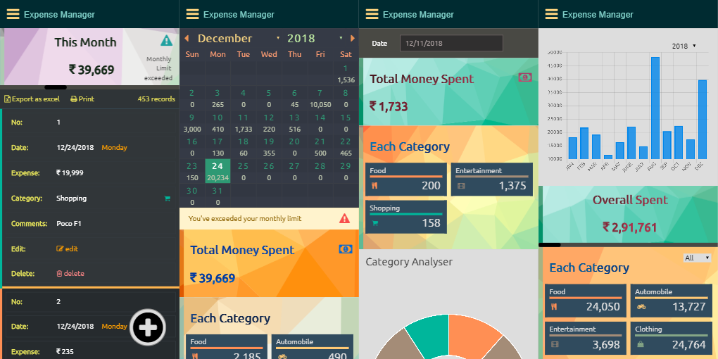

**Business Model:**

Think of a subscription as a contract between you and the customer. The customer agrees to pay for a service for a period and the business fulfils that offer as long as the customer completes their recurring payments. When the contract is up, the customer has the option to renew or cancel their subscription. So they can subscribe to the plan and get insight of their expense and where they can cut the expense.

